Sound - 01
CLASS 09 - SCIENCE

 | Section A
 | Question No. 1 to 4 are based on the given text. Read the text carefully and answer the questions: Work is closely related to energy . The work - energy principle states that an increase in the kinetic energy of a rigid body is caused by an equal amount of positive work done on the body by the resultant force acting on that body. | [4]
1 | Define potential energy.
2 | Give an example where potential energy is acquired by a body due to a change in its shape.
3 | A skier of mass 50 kg stands at A, at the top of a ski jump. He takes off from A for his jump to B. Calculate the change in his gravitational potential energy between A and B. 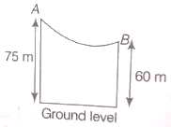
4 | An object of mass, m is moving with a constant velocity, v. How much work should be done on the object in order to bring the object to rest ?
 | Question No. 5 to 8 are based on the given text. Read the text carefully and answer the questions: An old man takes 10 minutes to do a particular work whereas a young man takes 5 minutes to do the same work. The rate of doing work of a young man is more than that of an old man. This rate of doing work is called power. Hence, power of young man is more than that of an old man. Thus, Power is defined as the rate of doing work.Power = $\frac{Workdone}{Timetaken}$ P = $\frac{W}{t}$ When work is done an equal amount of energy is consumed. Power is a scalar quantity. The SI unit of power is watt which is denoted by symbol W. watt is the power of an appliance which does work at the rate of 1 joule per second. watt = 1 joule/1 second watt = 1 joule per second. The power of an electrical appliance tells us the rate at which electrical energy is consumed by it. Watt is a small unit of power. Sometimes, bigger units of power called kilowatt (kW) and megawatt (MW) are also used. kilowatt = 1000 watts kW = 1000 W megawatt = 1000,000 watts 1MW = 10 $​^{6}$ W | [4]
5 | What is power?
6 | Define the SI unit of power.
7 | What does the power of an electrical appliance tell?
8 | How many watts are there in 1 kilowatt and 1 megawatt?
 | Question No. 9 to 12 are based on the given text. Read the text carefully and answer the questions: Electrical energy is energy derived as a result of the movement of electrically charged particles. When used loosely, electrical energy refers to the energy that has been converted from electric potential energy. 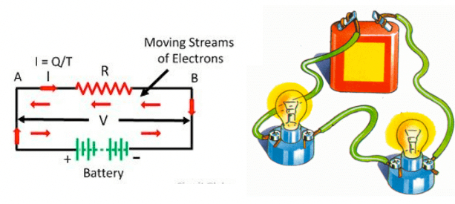 | [4]
9 | When 1 Joule of work is said to be done?
10 | An electric oven is rated 5000 W. How many units of electrical energy does it use in 2 hours?
11 | When a carpet is beaten with a stick, dust comes out of it. Explain.
12 | A lamp consumes 1000 J of electrical energy in 10s. What is its power?
 | Question No. 13 to 16 are based on the given text. Read the text carefully and answer the questions: Potential energy is stored energy that depends upon the relative position of various parts of a system. Spring has more potential energy when it is compressed or stretched. A steel ball has more potential energy raised above the ground than it has after falling to Earth. 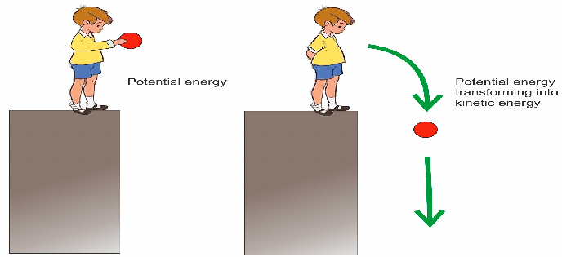  If a body falls from a height bounces from the ground and again goes upwards with loss of a part of its energy. | [4]
13 | How will its potential energy change?
14 | What are various energy conversions taking place?
15 | What will be its ultimate energy?
16 | The potential energy of a freely falling object decreases progressively. Does given violate the law of conservation of energy? Why?
 | Question No. 17 to 20 are based on the given text. Read the text carefully and answer the questions: Work is done whenever a force moves something over a distance . You can calculate the energy transferred, or work done, by multiplying the force by the distance moved in the direction of the force. Energy transferred = work done = force $×$ distance moved in the direction of the force. 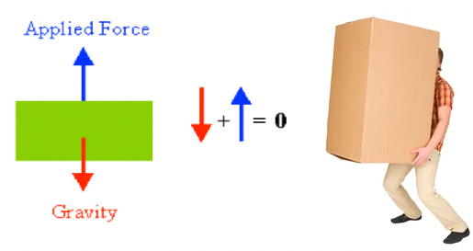  Four men lift a 250 kg box to a height of 1 m and hold it without raising or lowering it. | [4]
17 | Define work done.
18 | How much work is done by the men in lifting the box?
19 | How much work do they do in just holding it?
20 | Why do they get tired while holding it? (g = 10 ms$​^{−2}$ )
 | Question No. 21 to 24 are based on the given text. Read the text carefully and answer the questions: Work is the energy applied to an object as it moves some distance. The amount of work done is directly proportional to the magnitude of force applied, as well as the displacement of the object. In some cases, there may be an angle between the direction of displacement and the force vector.A body of mass 5 Kg is lifted vertically at a height of 12m. 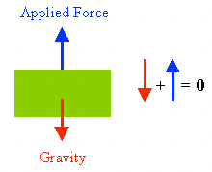 | [4]
21 | How much force is applied in this condition?
22 | How much work is done in lifting the body?
23 | What happens to the work performed?
24 | What are the quantities on which the amount of work done depends?
 | Question No. 25 to 28 are based on the given text. Read the text carefully and answer the questions: In physics, work is the energy transferred to or from an object via the application of force along with a displacement. In its simplest form, it is often represented as the product of force and displacement. A force is said to do positive work if (when applied) it has a component in the direction of the displacement of the point of application. A force does negative work if it has a component opposite to the direction of the displacement at the point of application of the force. 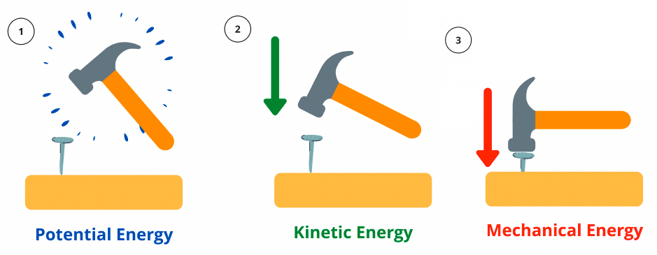 | [4]
25 | State the law of conservation of energy.
26 | Define mechanical energy.
27 | Calculate the energy in kWh consumed in 5 hours by four devices of power 600 W each.
28 | Can a body have energy, without having momentum? If yes, why?
 | Question No. 29 to 32 are based on the given text. Read the text carefully and answer the questions: Potential energy is storedenergythat depends upon the relative position of various parts of a system. Spring has more potential energy when it is compressed or stretched. A steel ball has more potential energy raised above the ground than it has after falling toEarth.  | [4]
29 | If a mass of 10 kg is dropped from a height of 50 cm, then find potential energy just before dropping.
30 | If a mass of 10 kg is dropped from a height of 50 cm, thenwhat is kinetic energy just on touching the ground?
31 | Also, what is the velocity with which it hits the ground?(take, q = 10 ms$​^{−2}$ )
32 | Can a body have energy, without having momentum ? If yes, why?
 | Question No. 33 to 36 are based on the given text. Read the text carefully and answer the questions: A car of mass 900 kg is travelling at a steady speed of 30 m/s against a resistive force of 2000 N, as illustrated in figure. 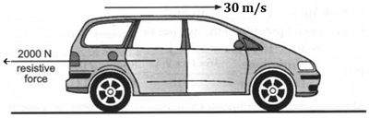 | [4]
33 | Calculate the kinetic energy of the car.
34 | Calculate the energy used in 1.0 s against the resistive force.
35 | What is the minimum power that the car engine has to deliver to the wheels?
36 | What form of energy is in the fuel, used by the engine to drive the car?
 | Question No. 37 to 40 are based on the given text. Read the text carefully and answer the questions: In physics, potential energy is the energy held by an object because of its position relative to other objects, stresses within itself, its electric charge, or other factors. The kinetic energy of an object is the energy that it possesses due to its motion. It is defined as the work needed to accelerate a body of a given mass from rest to its stated velocity. A car is moving on a levelled road and gets its velocity doubled. 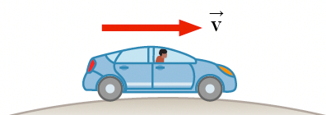 | [4]
37 | How would thepotential energy of the car change?
38 | Howwould the kinetic energy of the car change?
39 | How will its momentum change? Give reasons for your answer.
40 | What is the relation between mechanical energy, potential energy, and kinetic energy?
 | Question No. 41 to 44 are based on the given text. Read the text carefully and answer the questions: A vehicle of 1 tonne travelling by a speed of 60 ms$​^{−1}$ notices a cow on the road 9m ahead applies brakes. It stops just in front of the cow. 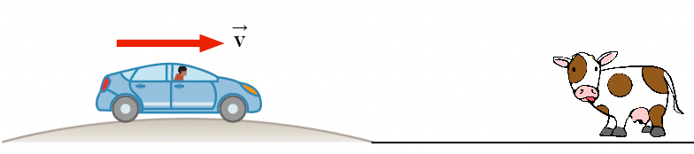 | [4]
41 | Find out the KE of the vehicle before applying brakes.
42 | Calculate the retarding force provided by the brakes.
43 | How much time did it take to stop after the brakes were applied?
44 | What is the work done by the braking force?
 | Section B
45 | Fill in the blanks:  - The electrical energy used during a month is expressed in terms of ________.  - Work done is ________ when the force acts opposite to the direction of displacement.  - The energy transferred to an object is stored as ________ energy if it is not used to cause a change in the velocity or speed of the object.  - Work done is ________ when the force is in the direction of displacement.  - If we push a huge rock and it does not move despite all the effort then work is not done as there is no ________ of the rock.  - Suppose a baby is pulling a toy car parallel to the ground. He exertsa force in the direction of ________ of the car.  - The ________ energy of a moving body is measured by the amount of work it can do before coming to rest.  - When a body is moved on the ground by applying force, then work is done against ________.  - One ________ is the power of an appliance which does work at the rate of 1 joule per second.  - Work done is ________ when a force acts at right angles to the direction of motion of the body.  - ________ is defined as the rate of doing work or the rate of transfer of energy.  - When a force of 1 newton moves a body through a distance of 1 metre in its own direction, then the work done is known as ________.  - Energy is a ________ quantity.  - The energy of a body due to its motion is called ________ energy.  - Work is said to be done when force produces ________.  - The SI unit of power is ________.  - Onekilowatt - houris the amount of ________ energy consumed when an electrical appliance with a power rating of 1 kilowatt is used for 1 hour.  - The commercial unit of energy is ________. | [18]
 | Section C
46 | Match the following Column A with Column B: 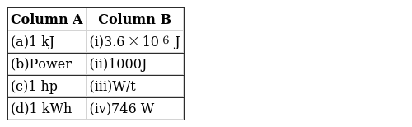 | [2]
47 | Match the following Column A with Column B: 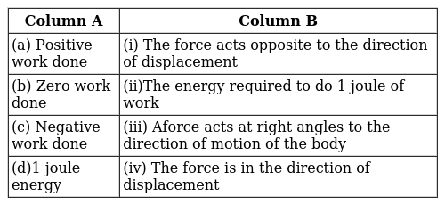 | [2]
48 | Match the following Column A with Column B: 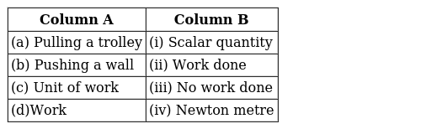 | [2]
49 | Match the following Column A with Column B: 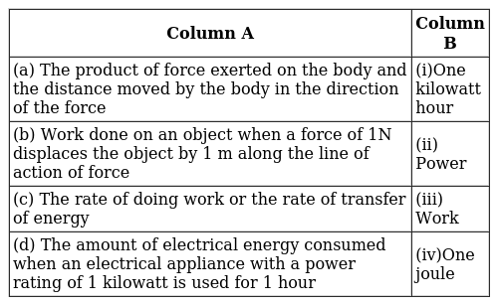 | [2]
50 | Match the following Column A with Column B: 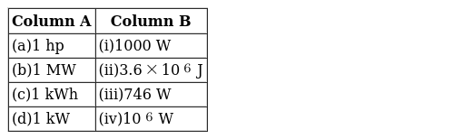 | [2]
51 | Match the following: 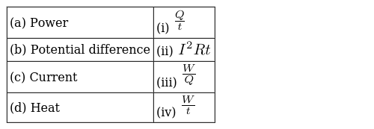 | [2]
52 | Match the following Column A with Column B: 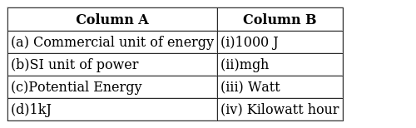 | [2]
53 | Match the following Column A with Column B: 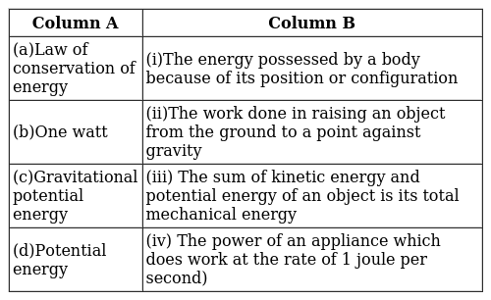 | [2]
54 | Match the following Column A with Column B: 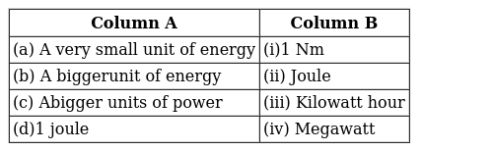 | [2]
55 | Match the following Column A with Column B: 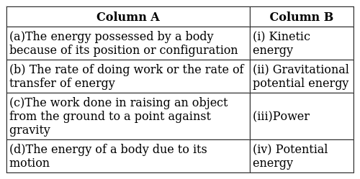 | [2]
56 | Match the following Column A with Column B: 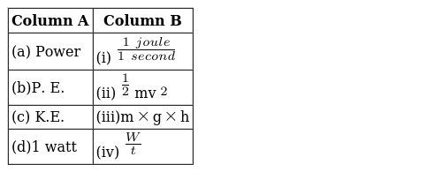 | [2]

